Box Plot (R generated) – Length in characters of Yelp review.text

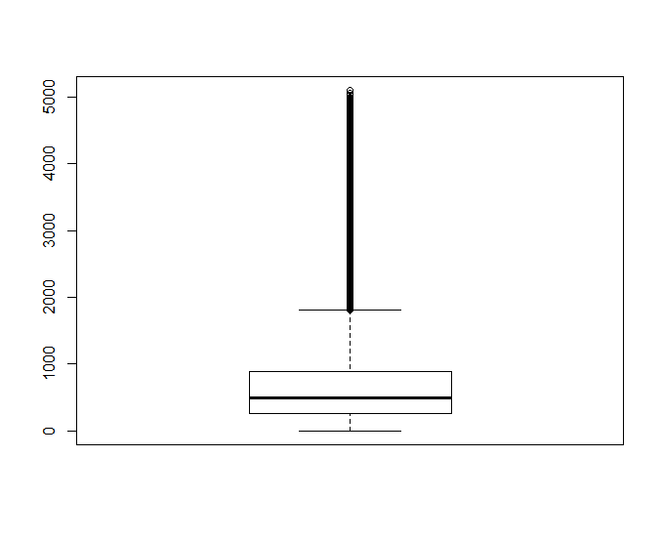

Summary Statistics of Yelp review.text length in characters



Histogram of review.text length (R generated)

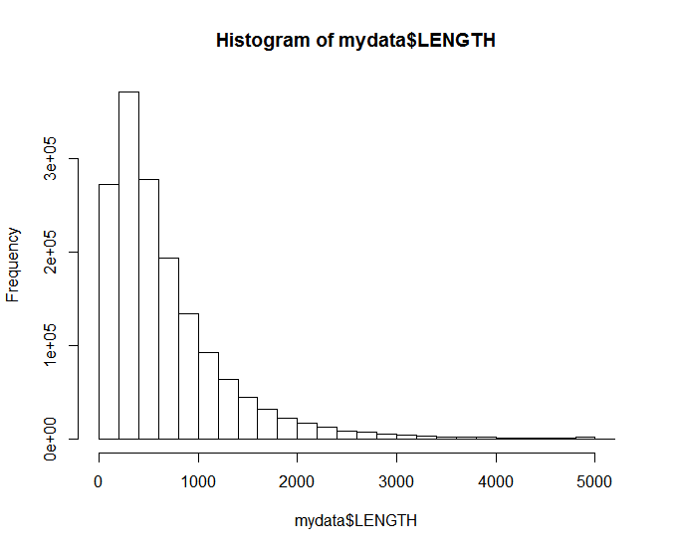

Histogram (Excel generated)

